Application by Frodsham Solar Ltd for Frodsham Solar (EN010153)
The Examining Authority’s second written questions and requests for information (ExQ2): Issued on 13 March 2026
Responses are due by deadline 5: 26 March 2026

Download a copy of this Microsoft Word version of the ExA’s written questions, enter your answers and save the document using an appropriate file name. You can then submit the completed document by choosing ‘Make a comment’ and selecting ‘Upload files’.

Abbreviations used:

  AEoI | adverse effects on integrity
  BESS | battery energy storage system
  BNG | biodiversity net gain
  BoR | Book of Reference
  BSMP | Battery Safety Management Plan
  CA | compulsory acquisition
  CA Guidance | Planning Act 2008: guidance related to procedures for the compulsory acquisition of land
  CFRS | Cheshire Fire & Rescue Service
  CNP | Critical National Priority
  CWCC | Cheshire West and Chester Council
  CWT | Cheshire Wildlife Trust
  DCO | Development Consent Order
  dDCO | draft Development Consent Order
  EA | Environment Agency
  EIA | environmental impact assessment
  EIA Regs | The Infrastructure Planning (Environmental Impact Assessment) Regulations 2017
  EM | Explanatory Memorandum
  ES | Environmental Statement
  ExA | Examining Authority
  NPS | National Policy Statement
  NPS EN-1 | Overarching National Policy Statement for Energy
  NPS EN-3 | National Policy Statement for Renewable Energy Infrastructure
  NPS EN-5 | National Policy Statement for Electricity Networks Infrastructure
  NSIP | Nationally Significant Infrastructure Project
  oCEMP | Outline Construction Environmental Management Plan
  oDEMP | Outline Decommissioning Environmental Management Plan
  oOEMP | Outline Operational Environmental Management Plan
  oLEMP | Outline Landscape and Ecology Management Plan
  oCTMP | Outline Construction Traffic Management Plan
  OL | Order Limits
  PA2008 | the Planning Act 2008
  PRoW | public right(s) of way
  ExQ (1, 2) | The Examining Authority’s first or second written questions
  FLL | functionally linked land
  FRA | flood risk assessment
  gCO_{2e}/kWh | grams of carbon dioxide equivalent per kilowatt-hour
  ha | hectare
  Habitats Regs | The Conservation of Habitats and Species Regulations 2017
  HE | Historic England
  HRA | habitats regulations assessment
  ISH | issue specific hearing
  km | kilometre
  LWS | local wildlife site
  MW | megawatts
  MWh | megawatt hours
  NBBMA | Non-Breeding Bird Mitigation Area
  NBBMS | Non-Breeding Bird Mitigation Strategy
  PV | photovoltaic
  NE | Natural England
  NH | National Highways
  NPA 2017 | Neighbourhood Planning Act 2017
  RSPB | Royal Society for the Protection of Birds
  SADA | solar array development area
  SoCG | statement of common ground
  SoS | Secretary of State
  SPA | special protection area
  SPEN | Scottish Power Energy Networks
  SSSI | site of special scientific interest
  tCO₂e | tonnes of carbon dioxide equivalent
  TP | temporary possession
  UK | United Kingdom
  UUW | United Utilities Water Limited
  UXO | unexploded ordnance
  WFD | Water Framework Directive
  oWSI | Outline Written Scheme of Investigation
  ZoI | zone of influence

The Examination Library
References in these questions set out in square brackets (for example [APP-010]) are to documents catalogued in the Examination Library. The Examination Library can be obtained from the following link: EL web link
It will be updated as the examination progresses.
Index
1. General and cross-topic questions 5
2. Principle of Development and Need 6
Effects on climate change 6
Site selection and alternatives 6
Decommissioning 7
3. Ground conditions 8
4. Biodiversity and ecology 9
Biodiversity Net Gain (BNG) 9
Mitigation measures 15
5. Habitats Regulations Assessment 17
6. Historic environment 19
Historic environment 19
7. Landscape and visual 20
Landscape and visual 20
8. The water environment 20
Flood risk 20
9. Other planning issues 21
Air quality 21
Glint and glare, aviation and defence 21
Green Belt 21
Human health, fire risk, safety and security 21
Noise, vibration and nuisance 21
Socio-economics and public rights of way 21
Traffic, transport, and access 22
Cumulative and inter-related effects 22
Good design 23
10. Compulsory acquisition and related matters 24
Compulsory acquisition and related matters 24
11. The draft Development Consent Order (DCO) 25
General matters 25
Articles 25
Requirements 25
Schedules 25

ExQ1 | Question to: | Question:

1. General and cross-topic questions
 | Applicant  All interested parties (IPs) | Solar Roadmap 2025  The applicant and all interested parties are invited to make any comments or representations about the Solar Roadmap 2025 and its applicability and implications for the proposed development. This is across all topics but, most notably, the areas of need, alternatives and waste management are likely to require some explanation and commentary.
 | Applicant | Grid connection statement  At present, the grid connection statement [APP-145] predicts part energising of the project in 2029, with full construction completed 2030. The actual grid connection date is 2029 as per paragraph 2.1.4.  The ExA notes that the examination completes on 30 April 2026, the recommendation report is due with the SoS by 30 July 2026 and, assuming the SoS issues a decision in 3 months, a decision made by 30 October 2026.  Assuming pre-construction works commence immediately on the day of the decision, the skylark mitigation area would take time to establish (6 months – April 2027), the Non-Breeding Bird Mitigation Area (NBBMA) is said to require 6-9 months (January 2028) to establish, then construction would be 30 months (June 2030). This timetable assumes a smooth running and immediate attention to all works and activities but does not appear to account for avoiding the overwintering seasons (November to March) each year.  This seems ambitious. Is the grid connection date secure?  Further to that, on the basis of the above, the NBBMA would be delivered between April 2027 and January 2028. Are you confident that the Runcorn Spur Pipeline, if approved, would be built in advance of these dates?
 | Applicant  Frodsham Wind Farm Ltd | Any remaining issues  Frodsham Wind Farm Limited submitted a relevant representation [RR-047] to the examination, but there are no further submissions expressly recorded in the examination. The ExA notes [RR-047] placed a holding objection to the proposed development. Is there still an objection, or is there now common ground?

2. Principle of Development and Need
Need case
 | Applicant | Capacity and upper limits  No energy cap is proposed for the project, allowing the solar farm to produce increased energy yields in the future following maintenance upgrades and panel replacements. This does however raise a few questions:  - When the cabling for the development is initially laid, what capacity would the cables be able to manage (for example, would the cables be fitted with a greater carrying capacity than what would be generated at the onset of the proposal, thus reducing the need to dig them up when the panels are replaced)?  - Regardless of what generation capacity is available now or in the future, would the project be restricted or constrained by the National Grid connection offer? Would you need to renegotiate the terms of that connection agreement before undertaking major replacement works?  - Would any future increases in energy yield be in any way constrained by capacity at the SPEN Frodsham Substation?  - Would the private wire agreements (if any) subvert the need for any renegotiation of the grid connection agreement?  - It is noted that in table 2-13 [APP-035] the battery energy storage system (BESS) is rated to have an operational lifespan of 10-20 years. Is it also the intention, as part of the major replacement works, to upgrade the BESS so as to increase its capacity (from 100MW and 400MWh) or would those parameters not change? Taking the lower end of that lifespan, could that mean the BESS would be replaced 4 times over the course of the project?

Effects on climate change
 | Applicant | Commentary on case law  Could the applicant provide comment in light of the recent cases of R (on the application of Finch on behalf of the Weald Action Group) v Surrey County Council [2024] UKSC 20 and Friends of the Earth Ltd and South Lakeland Action on Climate Change v SSLUHC [2024] EWHC 2349 (Admin), and whether these cases have any implications for the assessments of greenhouse gas emissions?

Site selection and alternatives
 | Applicant | Battery Energy Storage System (BESS)  It is acknowledged that the final decision on whether to develop the BESS under Work No.2A or work No.2B would be made at detailed design stage should development consent be forthcoming. At present, however, is the applicant any closer to fixing the location?
 | Applicant | Determination of what constitutes an alternative  The ExA acknowledges the applicant’s answer to ExQ1 question 8.2.5 regarding defining a 5km search area [REP2-003]. However, there are several further questions arising from this:  - Section 1.2 [APP-053] describes the applicant’s methodology to assessing alternatives. The ‘methodology’ does not describe a process of alternative site assessment, but rather straight away promotes the application site as the best option from a commercial perspective only. The way section 1.2 is written reads could be taken as conclusions rather than the method taken to appraise and sift potential sites. Do you have any comments on this?  - In paragraph 1.2.8 [APP-053], the applicant states: “Having secured the opportunity at the Site, the Applicant needed to ensure there was the necessary infrastructure and capacity within the transmission and distribution network to accommodate the electricity generated.” In light of this statement and the later sections of the ES Chapter on Alternatives promoting the application site, is it reasonable to conclude that there was, in fact, no real consideration of alternatives because there was already commitment, financial or otherwise, in the application site itself? Were options B and C ever realistic propositions if the application site had already been secured?  - In paragraph 2.4.9 [APP-053], the applicant declares that Option A within the search area is superior except for matters of ecology and flood risk. With regard to ecology, given the international importance of the Special Protection Area and the neighbouring Site of Special Scientific Interest (SSSI) and there was an existing area purposefully set aside for environmental mitigation related to the Frodsham Wind Farm, the ExA is unclear how the applicant a) gave weight to such considerations in the optioneering process and b) reconciled that direct interference with land in the SSSI and functionally linked land was preferred. Provide more detail on this with a clear rationale.  - Can the applicant provide the calculations that relate to transmission losses? The ExA is not wholly convinced that the transmission losses are so significant past the 5km point to make a project beyond this unviable, unattractive or inefficient.  - There are overhead power lines and pylons in existence stretching to the east and to the west. Was a direct connection into the overhead network ever considered? If not, why not?
 | Applicant | Site of Special Scientific Interest  Having determined that option A was to be the preferred option, the ExA notes that table 2.2 [APP-053] states: “The southern fringe of the Mersey Estuary Site of Special Scientific Interest (SSSI) is located within the northern extent of Option Area A.” The ExA also notes the same table, in respect of Option B, states: “a large solar farm development could be accommodated within this Option Area without affecting these SSSIs.”  Set out clearly why the ‘southern fringe’ was not excluded from the project site and why a large solar farm could not be accommodated at the project site without affecting the SSSI, just as in option B.
 | Applicant | Land at the Frodsham Wind Farm  Knowing that the Frodsham Wind Farm had land designated as a mitigation area and that land had been modified and improved to support wildlife as a means of mitigation for the wind farm (particular emphasis on Cell 2), why was this area not avoided when undertaking the site selection process? Justify why the site selection and order limit refinement process did not seek to exclude this land and set out what other alternatives were considered to using the said land.
 | Applicant | Initial scope of substations  Whilst ES Chapter 3 [APP-036] and its accompanying appendix [APP-053] discuss the suitability of the SPEN Frodsham Substation and options A, B and C, no information is volunteered about whether other substations were considered. Explain why or what research was actually done with regards to alternative substations other than the SPEN Frodsham Substation.
 | Applicant | Contamination and alternatives  In comparing options A, B and C, there does not appear to have been any consideration of historic land uses or historic contamination. Representations to the examination, particularly at issue specific hearing 2 (ISH2), suggest a high level of known contaminants in and around the project site. In determining and considering alternatives, was any weight given to this environmental constraint on the option A land that presumably does not exist on either options B or C?
 | Applicant  Cheshire West and Chester Council (CWCC)  Cheshire Wildlife Trust (CWT)  Natural England (NE)  Royal Society for the Protection of Birds (RSPB)  Mr Dermot Smith | Alternatives and Habitats Regulations Assessment (HRA)  Several IPs have suggested incorporating Cell 2 into the NBBMA so as to avoid an Adverse Effect on Integrity occurring. Could this be an alternative solution that could mitigate harm arising to the Mersey Estuary Special Protection Area (SPA)? With regard to the consideration of alternative solutions in relation to the Habitats Regulations, explain the importance and relevance of this alternative to the SoS’ decision-making process for this project.

Decommissioning
 | Applicant | Re-powering  In the document about Future Baseline Decommissioning [REP4-054] there is discussion about whether or not the Frodsham Wind Farm would be decommissioned or re-powered. The applicant’s position during the examination is a belief that the wind farm would be re-powered because of the national drive for renewable energy and that the need would continue in the future.  Applying that same rationale regarding the need for renewables going forward and the likelihood of projects being re-powered, on what basis should the ExA consider the proposed development to be ‘temporary’? Whilst there is a decommissioning date written into the dDCO, if the applicant is confident the Frodsham Wind Farm would be re-powered under current national policy, what is to stop the proposed development being re-powered? In such circumstances, would not the label of ‘temporary’ be misplaced in all ES assessments?

3. Ground conditions
 | Applicant  Frodsham Wind Farm Limited  CWCC | Extent of contamination  The examination has received strong concerns from Councillor Mrs Sumner regarding contaminated land in, at and around the proposed development Order limits. To assist the ExA understanding the baseline, and perhaps to give reassurance to the interested party regarding the likelihood of encountering high concentrations of contamination, could any contaminated land reports, surveys and investigations for the Frodsham Wind Farm investigations and any other relevant investigations be submitted to the examination? An accompanying commentary from the submitting party would be welcomed to clarify what, if any, the findings show. The relevant investigations to include are those listed in table 3.1 of Appendix 10-1 of the ES [APP-096]:  - Groundsure Report Datasheet GSIP-2023-13776-14419 (SADA) GSIP-2023-13776-14430 (Private Wire Connection and Main Site Access); June 2023 (provided in Appendix B)  - Frodsham Wind Farm Preliminary Site Investigation, March 2014  - Frodsham Wind Farm Phase 2 Site Investigation, April 2015  - Frodsham Wind Farm. Condition 38: Hydrocarbon Contamination within Cell 3, April 2015  *The ExA notes that MSCDDG Cell 3 Summary of Chemical Testing (March 2025) has already been provided in Appendix G [APP-097] and that the Wildfowlers Land – Summary of Soil Chemical Results Recorded in June 2024 Ground Investigation (July 2024) has already been provided in Appendix H [APP-097].
 | Applicant | Chemicals referred to by interested parties in the examination  The ExA notes the applicant’s response to action point 43 was provided in Appendix D [REP4-055] for arsenic, vinyl chloride and carbon tetrachloride. The ExA would like the applicant to expand this appendix to include the following chemicals which have been raised by interested parties as a concern, within the examination:  - chloroform  - hydrogen chloride  - polychlorinated biphenyls

4. Biodiversity and ecology

Biodiversity Net Gain (BNG)
 | Applicant | BNG unit baseline  Explain why the baseline habitat units within the BNG assessment in section 3.1.2 of the: Biodiversity Net Gain Report [REP4-038] have changed for deadline 4, see screen shot below. Fully explain the basis of the recalculation.  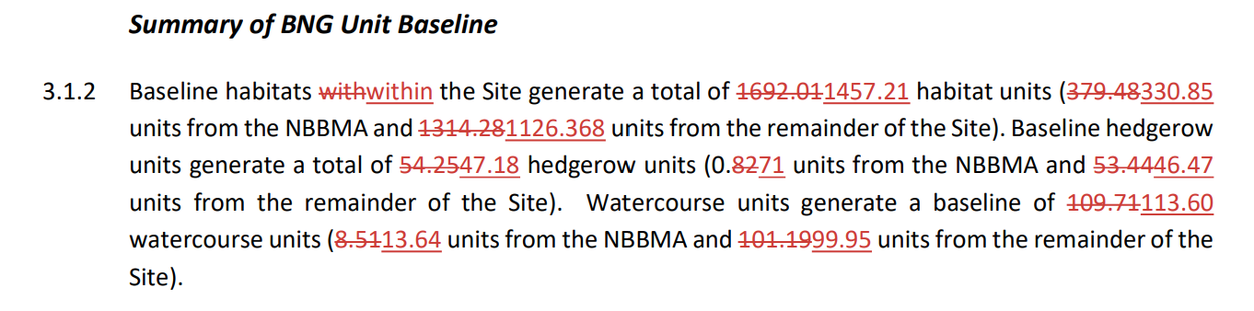
 | Applicant | Post works BNG summary  Explain why the BNG units within the BNG assessment in sections 5.1.3 to 5.1.6 and section 6.1 of the Biodiversity Net Gain Report [REP4-038] have changed for deadline 4, see screen shot below. Fully explain the basis of the recalculation, including the changes within tables 6.1, 6.2 and 6.3.  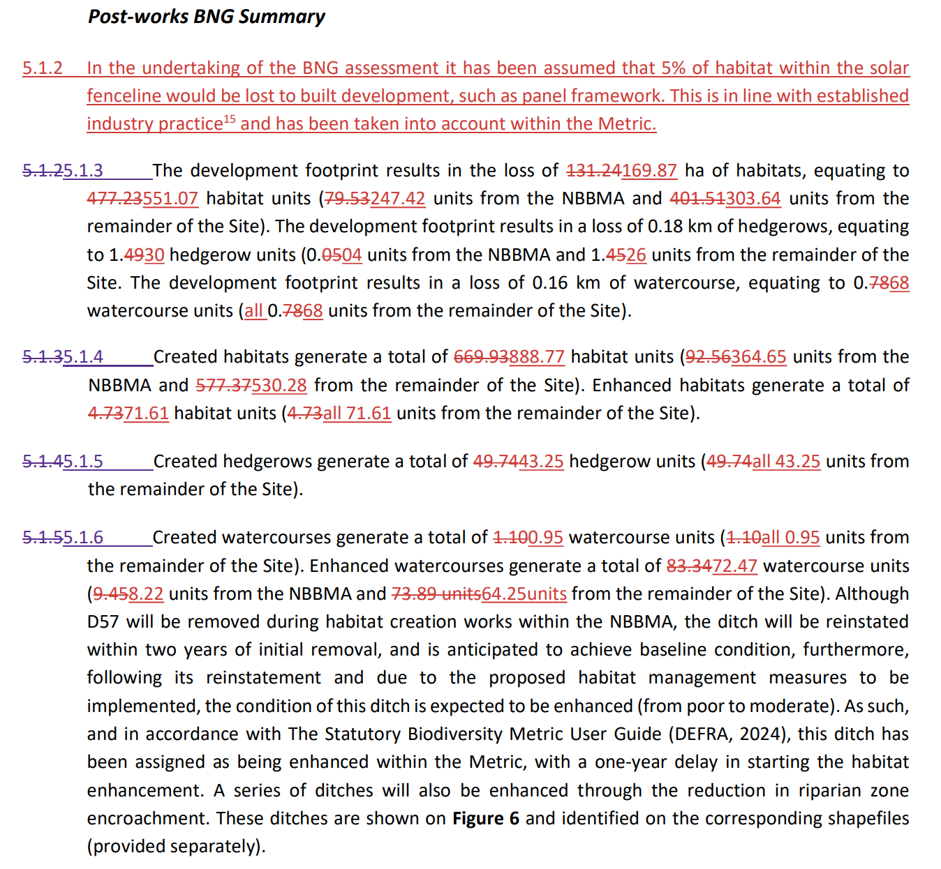  and  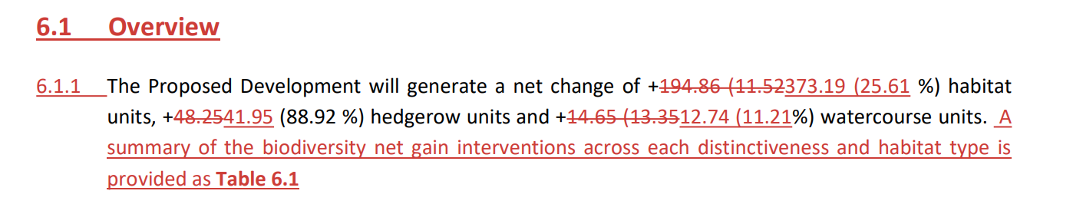
 | Natural England (NE)  CWCC  CWT | Classification of reedbeds within the applicant’s BNG assessment  The applicant has provided further information on the classification of reedbeds within Annex 3 of its deadline 4 Biodiversity Net Gain Report [REP4-038]. This states that:  ‘Following receipt of Relevant Representations by CWACC a review has been undertaken of particular reedbed habitats against both JNCC and UKHab definitions. Following the review, an area formerly classified as reeded located within Frodsham Windfarm East has now been reclassified as g3.16 instead due to not meeting soil moisture criteria. Further, several areas which may meet the UKHab definition of reedbed, are not considered priority habitat but rather smaller stands of reed’.  - Do you agree with the applicant’s classification of reedbed in general?  - Do you agree with the applicant’s classification of reedbed at the Frodsham Windfarm East area described in table 1 [REP4-038] and above as not meeting the definition of reedbed?  - Do you agree with the approach the applicant has demonstrated to the overall consideration of reedbed within the applicant’s deadline 4 Biodiversity Net Gain Report [REP4-038]?
 | Applicant | Trading rules – net loss of reedbed habitat  The applicant states in section 6.3 of the deadline 4 Biodiversity Net Gain Report [REP4-038], that there would be a deficit of reedbed habitat type and scrub broad habitat type, see screen shot below.  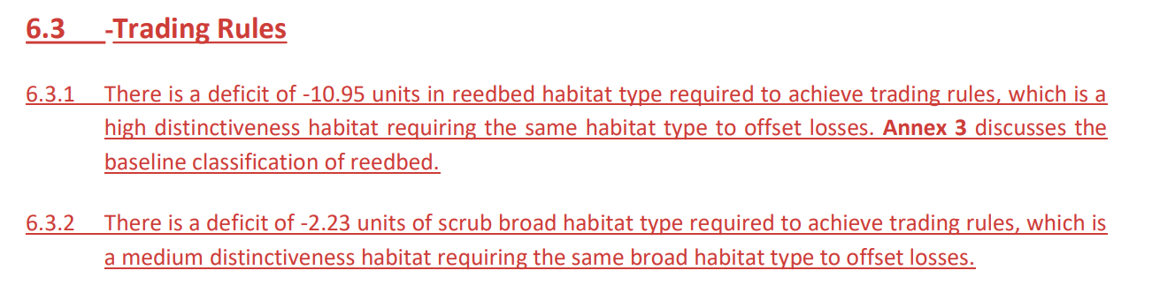  Table 6.1 [REP4-038] provides a summary of area and unit change for each habitat type within the draft order limits. A screen shot is provided below for the first line concerning reedbeds.  - Can the applicant explain why post development there would be an increase in reedbed area but a decrease in reedbed units? What is it about the properties of the post development reedbed area that cause the calculation of resulting BNG units to fall?  - The ExA acknowledges that BNG requirements are not yet mandatory for NSIP applications and that the applicant has clearly stated that the trading rules for reedbeds are not proposed to be met. Nevertheless, the mitigation hierarchy should still be adhered to. The ExA would like the applicant to explain how much reedbed is proposed to be lost for each of the areas given below and provide justification as to why these areas of reedbed are proposed to be lost and not retained:  - Reedbed 12 shown in the NBBMA (see screenshot below from Map 2 of Figure 3 of the deadline 4 Biodiversity Net Gain Report [REP4-038])  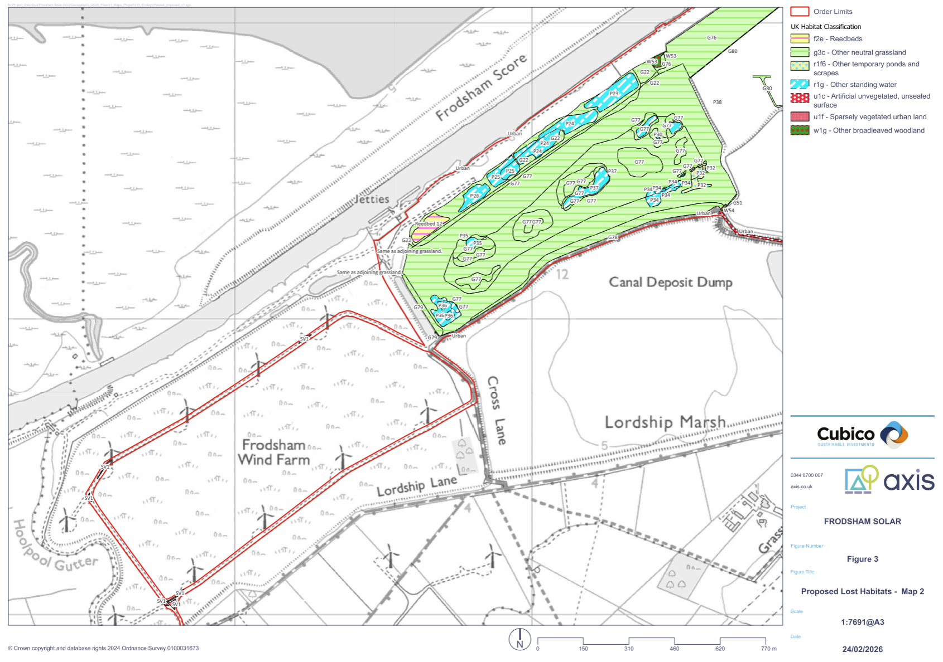  - Reedbed 40 (see screenshot below from Map 4 of Figure 3 of the deadline 4 Biodiversity Net Gain Report [REP4-038])  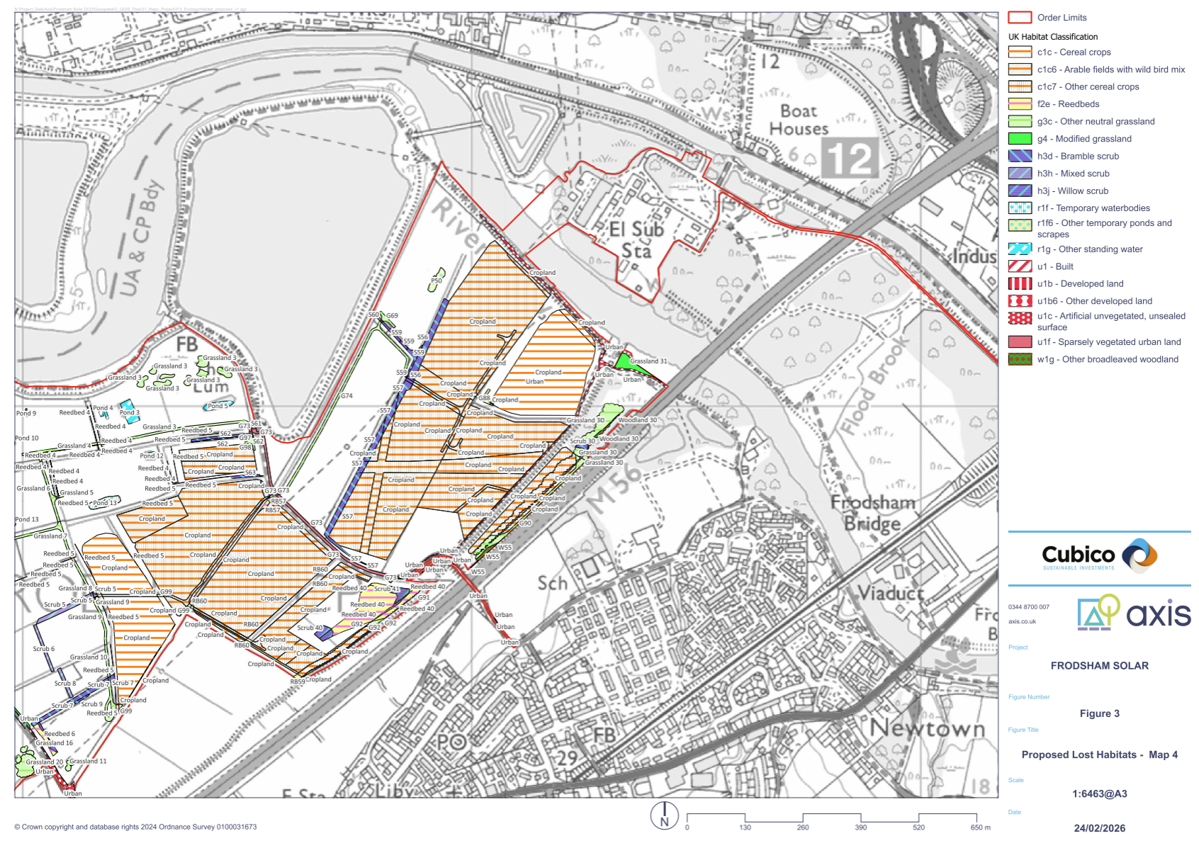  - Reedbed 7 near Marsh Farm (see screenshot below from Map 3 of Figure 3 of the deadline 4 Biodiversity Net Gain Report [REP4-038])  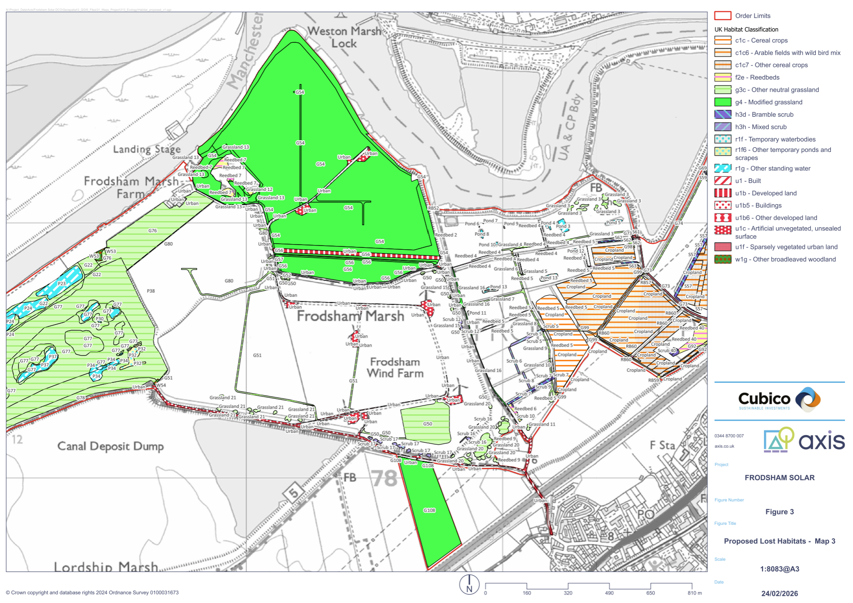  - Can the applicant explain why it has not proposed more areas of reedbed to be retained or the creation of more reedbed habitat to achieve at least a no net loss? Would this be possible? If not, explain why not.  - Can the applicant explain why it has not proposed more areas for the retention or creation of scrub broad habitat to achieve at least a no net loss? Would this be possible? If not, explain why not.  - Can the applicant explain how it has adhered to the principle of the mitigation hierarchy in relation to these two habitat types (reedbed and scrub broad habitat)?
 | NE  CWCC  CWT | BNG metric Rule 4  The applicant has provided further explanation of its application of Rule 4 to the proposed development within its deadline 4 Biodiversity Net Gain Report [REP4-038], citing a case study from NE in Annex 4.  - Do you agree with the way the applicant has applied Rule 4 to the proposed development?  - Do you agree with the comparison the applicant has made between the proposed development and the case study in Annex 4?

Mitigation measures
 | Applicant | Damaged or end of life batteries  The ExA requests that the applicant:  - Acknowledges within the ES that batteries can cause chemical pollution and present a fire risk if not managed appropriately that could cause a decrease in water quality if any surface runoff became contaminated.  - Inserts within the Outline Battery Safety Management Plan [REP3-026] that where a battery storage area is provided external to the BESS unit, that it would be impermeable, covered and bunded, and that battery storage would be confirmed as part of the detailed design and submitted for approval by the EA in writing.
 | CWT | Area required for adequate skylark mitigation  In your deadline 4 submission [REP4-075] you state that:  ‘The literature commonly used to determine the necessary hectarage for skylarks states that a pair requires 3.3ha per territory. As there are 21 pairs of skylarks at peak count on the site, this would amount to about 70ha’.  Please provide the references for the literature that you refer to substantiate this position.
 | Applicant | Skylark mitigation area (SMA)  In your response to ISH2 action points [REP4-055] you state that:  ‘The SMA is not presented as replacing the entirety of 21 recorded (possible to probable breeding) territories across the Order Limits. Rather, it provides higher-quality breeding habitat (managed meadow grassland tailored to the species-specific needs) than the existing baseline sub-optimal arable land, thereby supporting improved breeding productivity per pair (which will breed several times across the breeding period). The focus of the SMA is maintenance of ecological and ornithological function and enhancement of breeding output successes’.  In ES Chapter 8: Ornithology section 8.8.40 [APP-041] you state that:  ‘Breeding skylark and lapwing would be permanently displaced from breeding within the SADA, depending on the time of year that construction works are undertaken. Skylarks will be temporarily displaced from nesting within the NBBMA but are likely to return once grassland establishes. It should be noted that, although skylarks are assumed to be permanently displaced from solar farms for nesting, skylark will still use operational solar farms, including as ‘nursery’ habitat for their fledged young (Fox, 2022). Areas of suitable nesting habitat will however remain available in retained open habitats onsite.’  In ES Chapter 8: Ornithology section 8.8.45 [APP-041] you state that:  ‘Skylarks are considered likely to continue to utilise marginal habitats and areas between solar panels in the SADA for foraging, and larger gaps between panelled areas are also potentially suitable for nesting birds. The enhancement works within the NBBMA will also provide suitable breeding habitat for skylark (c. 34 ha of grassland), so the skylark population would be maintained at similar levels to pre-development conditions.’  In ES Chapter 8: section 8.8.48 [APP-041] you state that:  The construction of the Proposed Development is therefore anticipated to result in minor adverse effects on skylark and lapwing, which is not significant.’  - If the SMA would not replace the entirely of the 21 recorded skylark territories area, how many skylark territories is it anticipated to mitigate for? What evidence is there that this improvement in quality of habitat would be sufficient to mitigate for said number of skylark territories?  - How many skylark territories are anticipated to be mitigated by the:  - NBBMA. Justify the number skylark territories anticipated to be mitigated given the habitat within the NBBMA would not be tailored to the species specific needs and maintained in the same way as the SMA.  - The marginal habitats, areas between solar panels and larger gaps. What area does this amount to? Justify the number of skylark territories anticipated to be mitigated given the habitat within these areas would not be tailored to the species-specific needs and maintained in the same way as the SMA.  - Clearly explain why the proposed SMA, NBBMA and other areas (marginal habitats, areas between solar panels and larger gaps) would be adequate to mitigate the construction and operational effects of the proposed development to skylark.  - You stated in response to questioning at ISH2 [REP4-057] agenda item 3f ii e regarding the adequacy of long-term management and monitoring for skylark, that:  ‘…success is primarily about maintaining the quality of the grassland habitat through the oLEMP management regime. He stated that there is no proposal for routine skylark nest surveys because locating nests is difficult and population counts can be variable; however, the measures proposed are widely adopted and well researched for conservation outcomes, and the Applicant has a high degree of confidence provided habitat quality is maintained.’  Can you explain how you can be confident adequate mitigation would be provided when significant sections of land incorporated to mitigate for the 21 skylark territories identified would not be managed to the same quality of grassland habitat as the SMA, which you have stated would not mitigate for the 21 territories alone?  - The ExA is not currently convinced the difficulty and scientific uncertainty cited by the applicant are sufficient reasons to exempt the need for monitoring. The ExA suggests the applicant incorporates a monitoring and reporting regime into the proposals to be able to evaluate whether or not the proposed development had provided sufficient mitigation for skylark if it were to be constructed, along with an adaptive management proposal including any necessary triggers, to be enacted if it were shown not to have been adequate. The ExA would like the applicant to clarify which organisation would undertake the monitoring and suggests that a sensible solution could be for the skylark mitigation monitoring to be part of the monitoring undertaken by the organisation responsible for the long-term management of the NBBMA. The ExA would like to point out to the applicant that monitoring, reporting and adaptive management measures were included by the Secretary of State in requirement (25) for farmland bird compensation in the Five Estuaries Offshore Wind Farm made DCO The Five Estuaries Offshore Wind Farm Order 2025.
 | CWCC | Mitigation for wintering wader species including golden plover, lapwing and curlew  CWCC’s representation at ISH2 highlighted ongoing concerns regarding mitigation proposals for wintering wader species including golden plover, lapwing and curlew.  - Can CWCC explain whether the proposed mitigation for skylark would also be appropriate for lapwing as the applicant suggests in ES Chapter 8 [APP-041]. If it is appropriate for wintering lapwing, would it also provide good habitat for wintering golden plover?  - Golden plover is listed as a qualifying feature of the Mersey Estuary SPA and curlew is listed as part of the waterbird assemblage in Table 8-8 of ES Chapter 8 [APP-041]. Can CWCC further explain its specific concerns regarding this species?
 | Applicant | Mitigation for wintering wader species including golden plover, lapwing and curlew  CWCC’s representation at ISH2 [REP4-074] highlighted ongoing concerns regarding mitigation proposals for wintering wader species including golden plover, lapwing and curlew. Can the applicant explain how sufficient mitigation would be provided for these species?
 | NE  RSPB  CWT | Mitigation for wintering wader species including golden plover, lapwing and curlew  Do you have any ongoing concerns regarding mitigation proposals for these species?

5. Habitats Regulations Assessment
 | RSPB | Confirmation of conclusions  Having read your deadline 4 response [REP4-067], you state: “Following consultation with our in-house Casework Team, and subject to the matters outlined in section (c), we are satisfied that the proposed enlarged NBBMA is capable of supporting the applicant’s conclusion of no Adverse Effect on the Integrity of the Mersey Estuary SPA.” In section (c) you request that the entirety of Cell 2 is incorporated into the NBBMA.  The ExA reads into this that, as the proposal currently stands, the RSPB considers an Adverse Effect on Integrity (AEoI) could not be ruled out because the entirety of Cell 2 is not included.  - Is that correct?  - If the applicant does not alter the project, and does not incorporate cell 2 into the NBBMA, would you object to the proposed development on the grounds of insufficient mitigation and an Adverse Effect on Integrity being unable to be ruled out?  - In light of (2) above, if the project is not altered to your satisfaction, would you pull out of any agreement for the RSPB to take over as the responsible conservation body?  - Elsewhere in your representation, it is stated “For RSPB to take any proposal through our internal approval procedures, we require a clear and detailed understanding of the mitigation design, management expectations, and long-term obligations.” Are you stating there is insufficient information at this time such that support cannot be garnered towards the project OR are you content that such detail could be developed at the detailed design stage of this project should development consent be forthcoming?
 | NE | Precise position clarification  In the deadline 4 response [REP4-069], you appear to agree with the applicant’s HRA as a whole and appears to endorse the conclusions that an AEoI can be ruled out. This position is reached because the Outline Non-Breeding Bird Mitigation Strategy (NBBMS) contains commitments in writing to secure a nature conservation body to take on the upkeep and maintenance of the Non-Breeding Bird Mitigation Area (NBBMA).  The RSPB was to be the nominated conservation body. However, the ExA directs your attention to their submission [REP4-067] and the question posed to the RSPB above. The RSPB, as can be seen, believes that the mitigation area should be expanded before it could be supported wholly.  In light of this, please respond to the following:  - Noting the ‘quality over quantity’ argument from the applicant, what is your position on the need (or otherwise) of incorporating all of Cell 2 into the mitigation area? Justify your response.  - If Cell 2 as a whole remained outside the scope of the NBBMA (i.e. as currently proposed) would you stand by your position that an AEoI would not occur? If so, why?  - If the project does not change and the RSPB is not willing to progress with the applicant, do you remain confident in the wording secured in the NBBMS?  - Set out any other agreements and disagreements or clarity on why NE’s position on AEoI is tenable in the circumstances.
 | Applicant | NBBMA and the mitigation hierarchy  - In light of the positions held by some interested parties that Cell 2 should be used for mitigation rather than as part of the solar array development area, can you state whether using all or part of Cell 2 for mitigation would or would not render the proposed development commercially unviable? If you consider it would, provide financial evidence to justify this position.  - The latter part of paragraph 4.2.24 of NPS EN-1 states:  ‘There may be exceptional circumstances where the mitigation could have a significant benefit and warrant a small  reduction in generation capacity and function. In these circumstances, the Secretary of State may decide that the benefits of the mitigation to reduce the effects outweigh the marginal loss of function’.  Would the use of Cell 2 for mitigation fit this definition? Justify your answer.
 | Applicant | Without prejudice derogations case  If agreement between the applicant, NE, RSPB, CWCC and the Cheshire Wildlife Trust cannot be reached on the potential for AEoI to the Mersey Estuary SPA and Ramsar site, the ExA requests that you submit a without prejudice derogation case into the examination by deadline 5 to satisfy the requirements of the HRA in the circumstance that the Secretary of State (SoS) decides there could be AEoI to the Mersey Estuary SPA and Ramsar from the proposed development. Interested parties would then be required to comment on the without prejudice derogation case at deadline 6 (22 April 2026) and the applicant would have the right of reply at deadline 7 (29 April 2026).
 | CWCC  CWT  RSPB  NE | Adaptive management approach to the NBBMA  The ExA is interested to understand your position on the adaptive management proposals from the applicant. The applicant proposed that the management of the NBBMA would be through an adaptive approach, setting out the detail in section 4.4 of the Outline Non-Breeding Bird Mitigation Strategy [REP4-048] which states that on-going conservation management of the NBBMA would be secured through Requirement 9(j) of the draft DCO and the final NBBMS would include an Adaptive Management Plan (AMP). The combination of Requirement 9(1) and (2)(j) means the final NBBMS and AMP would have to be agreed with consultees including NE and the RSPB and approved by CWCC as the Local Planning Authority.  - Is the detail on adaptive management throughout the Outline Non-Breeding Bird Mitigation Strategy [REP4-048] and particularly within section 4.4 which has been updated by the applicant at deadline 4, sufficient for you to have confidence that the AMP would ensure adequate mitigation could be achieved for all species of concern? If not, what additional measures would you like to see?  - Do you consider it likely that the AMP would be adequately flexible to provide the required mitigation? If this was not shown to be the case what would the implications be?
 | Applicant | Adaptive management approach to the NBBMA  Do you consider it likely that the AMP would be adequately flexible to provide the required mitigation? If this was not shown to be the case, what would the implications be and how could this be rectified?
 | CWCC  CWT  RSPB  NE | NBBMA mitigation verses compensation evidence provided by the applicant at deadline 4  The issue of whether the NBBMA proposal would be classified as mitigation or compensation according to the Habitats Regulations Assessment was discussed at ISH2. The applicant subsequently provided case law examples at deadline 4 [REP4-055].  In light of this evidence, do you agree with the applicant’s position that the NBBMA proposals would be mitigation and not compensation in relation to the HRA? If not, clearly explain why not.
 | Applicant  CWT  NE | NBBMA mitigation verses compensation positions  The ExA acknowledges the applicant’s deadline 4 submissions justifying why it believes the NBBMA would be classified as mitigation and not compensation [REP4-055]. CWCC has raised in its various representations that as Cell 3 would be lost and then reinstated this makes it compensation. Could you respond to this statement please.
 | Applicant | NBBMA long-term management  To give reassurance to the SoS that there would be an alternative if the RSPB were to withdraw its interest in long-term management of the NBBMA, can the applicant state whether it has spoken to any other organisations who would be suitable to act as a nature conservation body for the long-term management of the NBBMA?  If so, is the applicant in a position to name any of the other reserve organisations it has spoken to?  If the applicant has not spoken to any other organisations specifically, could the applicant name any organisations that could be potential candidates?
 | Applicant | NBBMS and funds  Can the applicant confirm, in light of the RSPB’s submission [REP4-067], that there would be a mechanism and security within the NBBMS for the payment of a “financial package” to the RSPB that ensures the long-term success of the mitigation measures?  If such a package is going to be paid for by the applicant (and bearing in mind the NBBMA is said to be mitigation for impacts the proposed development would have) should this be secured by a legal agreement or development consent obligation?
 | Applicant | RSPB requirements  In light of the RSPB’s list of requirements and stipulations [REP4-067], will the NBBMS, the extent of the NBBMA or the scope of the Works Plans be updated in any way? If you are not going to act upon the RSPB’s requests, set out a detailed justification as to why not and set out clearly why the SoS should trust in your position?
 | CWT | Highly Pathogenic Aviation Influenza (HPAI)  At ISH2, concerns were raised regarding the clustering of birds on a smaller parcel of land and the potential for HPAI, or other diseases, to spread more rapidly. Please set out clearly as to why you feel the risks would increase to an extent to be deleterious to the bird species involved, and comment on the position that the RSPB has taken [REP4-067] that HPAI risks would not be significant.
 | Applicant  NE | Flight lines  Provide comment on CWCC’s position [REP4-074] that flight paths would be disrupted through Cells 2 and 5 down to Cell 6, which CWCC states is a favoured cell by the birds.
 | Applicant | Timing and delivery  CWCC has identified that the NBBMA would take 6 to 9 months to deliver, but the applicant has committed to providing the NBBMA outside of the sensitive 6-month season [REP4-057]. Explain how the NBBMA delivery would be timetabled and the sequence of delivery works, and how these would avoid the sensitive seasons for birdlife.
 | CWCC | Baseline recreational pressure  Regarding CWCC’s position that there is a lack of baseline data relating to recreational use, does CWCC have any evidence of its own regarding recreation and tourism use that could inform the ExA as to current usage and pressures experienced in the locality?
 | Applicant | Effect of any required unexploded ordnance (UXO) detonations  During ISH2 the applicant confirmed that it would restrict any required UXO detonations to a time that was not sensitive to birds. The ExA would like this to be explained in some more detail to understand how this would work in practice alongside health and safety considerations for workers on the site and users of nearby public rights of way. The ExA considers there would likely be a need to make the UXO safe as soon as possible, without delay, regardless of the time of year.  - Explain how delaying any controlled planned UXO detonation for the benefit of ecological receptors would be practicable and realistic.  - Explain in more detail what is meant in section 8.2.66 of the Information to Inform the HRA [REP4-012] that any planned detonations would take account of sensitive receptors.  - Explain the apparent inconsistency between whether UXO detonations would be unplanned, accidental or planned events, stated in the first and last lines of section 8.2.66 of the Information to Inform the HRA [REP4-012]:  ‘a UXO detonation would represent an unplanned and (or) accidental event’, but then ‘a UXO specialist overseeing the works at all times during the construction phase and ensure that any planned detonations take account of sensitive receptors’.  The ExA expects that the UXO Management Plan which would accompany the final Construction Environmental Management Plan must include sufficient mitigation to render the accidental detonation of a UXO as close to zero as possible, for the safety of personnel.
 | NE | Effect of any required unexploded ordnance detonations  Could NE comment on the applicant’s approach to UXO detonations in relation to designated features of the Mersey Estuary SPA and Ramsar. Is NE content with the applicant's conclusions of no AEoI to the Mersey Estuary SPA and Ramsar site from the risk of UXO detonations?
 | Applicant,  CWCC,  Liverpool Bay CCS Limited,  NE | HRA in-combination effects  Please see the questions in section 2.9 of this document.

6. Historic environment

Historic environment
No questions on this topic at this time

7. Landscape and visual

Landscape and visual
 |  | No questions on this topic at this time

8. The water environment
Assessment
 | Environment Agency (EA) | Water Framework Directive (WFD)  Provide an update on whether the WFD Assessment [REP3-008] and its conclusions, as amended, now accord with NPS EN-1.

Flood risk
 | Applicant | EA issue ‘EA007’ relating to the position of bridge abutments and soffit levels  The EA’s deadline 4 submission [REP4-071] states clear actions that could be taken by the applicant to resolve issue EA007. Therefore, the ExA requests the applicant to:  - Update the design of CP22 to include a 300mm freeboard above the design flood level of Ince and Frodsham fluvial model.  - Submit the following documents into the examination:  - Integrity of New Bridges in Flood Event. Document 14740-WCD-XX-XX-TN-S-001  - The bridge design drawings: Proposed Crossing CP14 Elevation & Sections drawing 14740-WCD-XX-XX-SK-S-002  - Proposed Crossing CP22 Elevation & Sections drawing 14740-WCD-XX-XX-SK-S-003  - Proposed Crossing CP14 & CP22 Existing Sections drawing 14740- WCD-XX-XX-SK-S-004  - Proposed Crossing CP17 Elevation & Sections drawing 14740-WCD-XX-XX-SK-S-005  If the applicant chooses not to undertake the above, please provide a clear justification as to why not.
 | Applicant | EA issue ‘EA010’ relating to flood risk  The EA’s deadline 4 submission [REP4-071] states clear actions that could be taken by the applicant to resolve issue EA010. Therefore, the ExA requests the applicant to:  - Include the following wording within the outline Construction Environmental Management Plan (oCEMP), Commitment Register or draft DCO:  ‘the height of the bridge deck will not fall below 5.3m AOD based on current data, with designs to be refined for approval in writing by the EA at the detailed design stage’.  - Should the applicant include wording that outlines if at detail design stage the deck height would fall below 5.30AOD, then the wording within the oCEMP, Commitment Register or draft DCO should also include a commitment that an updated technical note ‘Integrity of New Bridges in Flood Event’ must be completed at the new deck height and submitted for approval by the EA in writing.  If the applicant chooses not to undertake the above, please provide a clear justification as to why not.
 | EA | Construction compound flood risk impact note  Given the applicant’s statement in the construction compound flood risk impact note in Appendix F of the applicant’s response to ISH2 action points [REP4-055] that the impact of the marginal land raising in the location of the construction compounds has not been factored into the hydraulic modelling, could the EA review the construction compound flood risk impact note and state whether or not it concurs with the applicant’s conclusion that floodplain displacement from the construction compounds would not increase flood risk elsewhere?

9. Other planning issues

Air quality
 |  | No questions on this topic at this time

Glint and glare, aviation and defence
 | CWCC | Updated Glint and Glare Assessment  Do you have any outstanding concerns following your review of the applicant’s updated Glint and Glare Assessment [REP4-016]? If yes, please set them out and how you think that they should be addressed.

Green Belt
 | Applicant  CWCC | CWCC’s Green Belt Assessment  CWCC has noted that this document is expected to be published for consideration by its Scrutiny Committee on 27 April 2026. The ExA assumes that, in accordance with the Local Government Act 1972, the draft would be published five clear days before the Committee meeting. If so, and given that the examination is scheduled to close on 30 April 2026:  - could CWCC provide a copy of this draft document to the applicant as soon as it is published and to the ExA at deadline 6 (Wednesday 22 April 2026);  - could CWCC and the applicant provide any observations on the draft document (insofar as it relates to the application site or the arguments that they have put forward) at deadline 7 (Wednesday 29 April 2026); and  - could CWCC provide details of the Scrutiny Committee’s decision in respect of the draft document at deadline 7?

Human health, fire risk, safety and security
 | National Highways | BESS and the Battery Safety Management Plan  Are you content with the amendment to Requirement 7 (Battery Safety Management) in [REP4-004]?
 | Applicant  Cheshire Fire & Rescue Service (CFRS) | CFRS  - Please provide a response to all matters addressed to CFRS in [EV10-024].  - Could the CFRS read Appendix D of the applicant’s submission at deadline 4 [REP4-055] and provide comment as to whether chemical concentrations of those recorded are of concern to CFRS in relation to a battery fire?  - Could CFRS read the applicant’s response to action point 42 on pages 28 to 30 [REP4-055] and respond as to whether it has any residual concerns about responding to a battery fire at the BESS in light of this information.

Noise, vibration and nuisance
 | CWCC | Nuisance  Are you satisfied with the updated wording of Article 8 in [REP4-004]?

Socio-economics and public rights of way
 | Applicant | Maintenance of Public Rights of Way (PRoW) during the construction and operational phases  Given comments from National Highways (NH) at deadline 4 [REP4-070] that any resurfacing of a bridge which forms part of the PRoW may impact the structure beneath, including compromising the waterproofing layer which sits just below the surface layer, the ExA requests that the applicant includes NH as a consultee in the outline Public Rights of Way Management Plan and named in Requirement 15 of the draft DCO as a consultee.
 | Applicant | Closure of the River Weaver  The applicant sets out six organisations that use the Weaver Navigation or the River Weaver in ES Chapter 12: Tourism and Recreation [APP-045]. The applicant confirms in section 12.8.65, that only two of these organisations use the section of the River Weaver adjacent to the site of the proposed development, Frodsham Kayaking and the Weaver Sailing and Ski Club. The applicant states in section 12.8.20 of ES Chapter 12 [APP-045] that construction works are not expected to have an impact on the activities of the Runcorn Rowing Club, the Danny Steamship, Mersey Ferries and Frodsham Water Sports which take place on the Weaver Navigation, the Manchester Ship Canal or upstream on the River Weaver.  - The ExA notes the information in Table 12-4 of ES Chapter 12 regarding engagement activities, but for completeness could the applicant confirm the consultation it undertook in relation to the proposed closure of the River Weaver with the Weaver Sailing and Ski Club and Frodsham Kayaking, including dates this occurred and the details of the proposed closure that were conveyed? Could the applicant confirm if any specific objections or concerns were received from these organisations regarding the temporary closure of the River Weaver?  - Again, the ExA notes the information in Table 12-4 of ES Chapter 12 [APP-045], but for completeness, could the applicant confirm the consultation it has undertaken in relation to the proposed closure of the River Weaver with these organisations to determine this conclusion, including dates this occurred and the details of the proposed closure that were conveyed? If the applicant’s attempts to contact any of the above organisation was not successful, as is stated in section 12.4.5 of ES Chapter 12 published in May 2025, has the applicant made any subsequent attempts to contact them since then? Did the applicant receive any objections or concerns from any of these organisations regarding the proposed closure of the River Weaver?
 | CWCC  Applicant | Proposed closure of the River Weaver  Is either the applicant or CWCC aware of any commercial use of the River Weaver that could be impacted by the proposed closure? If yes, has the applicant undertaken a socio-economic assessment of the potential impact of said closure on that commercial use? If not, why not.

Traffic, transport, and access
 | Applicant | Planned emergency use of Brook Furlong bridge and Weaver Lane bridge  The ExA notes that the Outline Operational Environmental Management Plan [REP4-028] refers to access to the Site for emergency vehicles from Frodsham in section 2.2 page 7. A qualification of that is then provided within sections 2.4.18 and 2.4.19. Can the applicant review section 2.2 and consider if clarification on emergency access should also be made there?
 | Applicant | Delivery of the car park on Moorditch Lane  - Given the updates to the Outline Operational Environmental Management Plan [REP4-028] which reduces the possibility of a car park being delivered at all, can the applicant confirm whether this change has any impacts of the conclusions of ES Chapter 12: Tourism and Recreation [APP-045]?  - ES Chapter 12 [APP-045] section 12.8.53 states that ‘formal car parking area(s) would also be provided…’). Could the applicant explain whether this refers only to the proposed car park for Moorditch Lane or whether there are other potential car parking areas proposed?
Waste
 | Applicant | Major replacement works  In [REP2-003, Q9.6.3] and in response to the Local Impact Report [REP3-042, point 23.9] you state that major replacement work campaigns (plural) would take place every 10-15 years. It was stated at ISH2 that only one major replacement campaign would take place over the lifetime of the project (for solar panels), in accordance with the table 2-13 in ES Chapter 2 [APP-035].  The ExA requests that either ES Chapter 2, or the Technical Note on Major Replacement Works or the dDCO are amended to make it crystal clear on the situation regarding major replacement works and their frequency. The applicant is also advised to submit a separate contextualised response with regard to how the approach to major replacement works would accord with the waste management policies and expectations of NPS EN-1 and NPS EN-3.
 | Applicant  CWCC | Post-project management  At deadline 3 [REP3-047, page 18], CWCC raised a concern that there was reliance on private agreements with landowners in respect to the situation at, and immediately after, decommissioning.  - Could CWCC elaborate on its concerns and whether they are fundamental or cause conflict with any national policy statement?  - Applicant, are you able to comment on this matter at all or, if possible, provide an extract of the heads of terms you have agreed with landowners that could give some clarity or comfort in this regard?
 | Applicant | Waste Management Plan  CWCC [REP4-074] has requested certain stipulations be added into the waste management plan, including an adaptive approach to deal with future waste streams. Incorporate these requests accordingly or, if not, explain with reasons.

Cumulative and inter-related effects
 | Applicant,  CWCC,  Liverpool Bay CCS Limited | Tripartite memorandum of understanding  With respect to the Runcorn Spur, the three bodies named in this question are requested to submit a joint statement setting out a clear pathway to resolving the approach to the cumulative effects assessment that, without prejudice to any party, accords with the Habitats Regulations and ensures an Adverse Effect on the Integrity of the Mersey Estuary Special Protection Area (and its functionally-linked land) could be ruled out.
 | NE | HRA in-combination effects from the Runcorn Spur pipeline  The ExA notes that you stated in your deadline 1 submission [REP1-056] in relation to issue NE35 HRA in-combination effects that:  ‘Natural England has ongoing concerns with regards to the potential impacts on the NBBMA as a result of the Runcorn CO₂ spur pipeline. We continue to encourage the applicants of both developments to work together to minimise impacts and welcome the joint working group proposed by the applicant. The applicant must consider any factors that may undermine the success of the proposed habitats within the NBBMA. If works to the pipeline are undertaken before or at the same time as the habitats within the NBBMS are created, this creates a risk for the applicant in terms of the success of the NBBMA. The route of the pipeline in its current form shows the route passing through the NBBMA between the Canal Pools area and the wetland habitats. It is not clear how locating the pipeline in this area will impact on the water supply mechanisms to the wetland habitats and how it may alter the movement of water within the NBBMA. We advise assessment of the in combination operational impacts of the pipeline should be addressed within the HRA’.  At deadline 2 you stated [REP2-009] in response to ExA written question Q5.1.5 regarding the in-combination assessment that:  ‘NE welcomes the additional information provided by the applicant with regards to in-combination however we consider that there are matters outstanding which require further consideration by the applicant. Our detailed advice is given within our WR’.  (NE’s written representation is REP1-056] quoted above).  NE did not submit a representation at deadline 3 but the applicant submitted an updated (unsigned) Statement of Common Ground between itself and NE which stated the following on this issue which was recorded as ‘amber’:  ‘NE require additional information in relation to matters NE35 and NE36.The Applicant has confirmed within its written responses to the NE Written Representation and also within the updated HRA how, once implemented, the pipeline would not affect the functioning of the NBBMA’.  Your deadline 4 submission states [REP4-069] that you believe the matter regarding HRA in-combination effects of the Runcorn Spur pipeline is now resolved due to the additional information provided by the applicant and the clarification provided within the HRA and confirmed the issue as ‘green’.  Particularly in light of question 2.9.15 above, can you explain in more detail the reason you believe the matter regarding HRA in-combination effects of the Runcorn Spur pipeline is now resolved. The ExA would like to understand what has changed since you made your deadline 1, 2 and 3 submissions quoted above to bring NE to its current conclusion.
 | Applicant | NBBMA +  The ExA is slightly confused by the applicant’s position that, in the ‘after scenario’, the proposed development plus the NBBMA would not lead to a cumulative effect as indicated [REP1-041]:  “As such, in the After Scenario, the NBBMA will be an ecological future baseline for the Runcorn Spur Pipeline to consider. Put another way, there can be no ‘Runcorn Spur Pipeline plus NBBMA’ cumulative/ in-combination effect, as the NBBMA does not cause effects.”  - As the ExA understands it, the cumulative effect is upon the birds, first by being displaced and re-provided for by the proposed development on the NBBMA, only then to be disturbed and potentially displaced from the NBBMA by construction activities by the Runcorn Spur. Should then consideration be given to the cumulative effect of the proposed development plus the Runcorn Spur upon SPA bird mitigation features? If not, why not?  - Once the NBBMA is established and a conservation body (potentially the RSPB) takes over long term management and maintenance of the feature, would the applicant retain any interest, responsibility or liability over the NBBMA or the success of it as effective mitigation? If so, then would it not be the applicant responsible for restoring the NBBMA to its original condition prior to the Runcorn Spur being laid? If not, then which organisation would be responsible for restoring the NBBMA?

Good design
 |  | No questions on this topic at this time

10. Compulsory acquisition and related matters

Compulsory acquisition and related matters
 | Applicant | Justification for CA of Land  Paragraph 1.1.6 of the Statement of Reasons (SoR) [APP-018] states that the current design for the proposed development would enable the generation of approximately 147 megawatts (MW) of electricity, that the precise generating capacity and storage capacity will be subject to detailed design, but that at present the grid connection offer from the District Network Operator (DNO) is for 100 MW export and 50 MW import. Paragraph 1.1.3 of the SoR says that a private wire electricity connection would provide “the opportunity” to supply renewable energy generated by the proposed development directly to nearby industrial businesses. In that context:  - is Plot 3-36 (Cheshire Green Property Ltd) likely to be needed to achieve the 100 MW of electricity for export to the grid?  - with reference to paragraph 3.15 of [REP4-056], is Plot 3-36 needed to achieve the applicant’s expected grid connection date?  - are there any agreements in place for the supply of energy to nearby industrial businesses? If yes, for how many MW of electricity?  - please provide any examples of where overplanting has been accepted as a justification for the compulsory acquisition of land.
 | Applicant | Critical National Priority  In your opinion, where Critical National Priority (CNP) Infrastructure is proposed, does the CNP status alone mean that compulsory acquisition of all land within the order limits should be confirmed? If yes, please set out your justification and any policy or guidance that supports your position. If no, please explain the other considerations that should be taken into account.
 | Applicant  INOVYN Chlorvinyls Limited | Option Agreement and Deed of Easement  Please provide an update on negotiations in respect of INOVYN Chlorvinyls Limited’s interests.
Protective Provisions
 | EA | Protective Provisions  Having regard to your position in respect of the disapplication of flood risk activity permits, are you content with the Protective Provisions for the Protection of the EA at Schedule 23 of the dDCO [REP4-004]?
 | National Highways (NH) | Protective Provisions  Having regard to your position in respect of the Brook Furlong and Weaver Lane bridges, are you content with the Protective Provisions for the Protection of National Highways Limited at Schedule 27 of the dDCO [REP4-004]?

11. The draft Development Consent Order (DCO)

General matters
 | All interested parties and Statutory Undertakers | Residual issues with the dDCO  The DCO [REP4-004] has been updated and progressed over the past few deadlines. A proportion of what has been requested by interested parties has been included in the Order, another proportion has been addressed through the updating of associated management plans and other elements the applicant has resisted with reasons. Under this question, please:  - Outline any remaining or residual issues that you have with any articles, requirements or schedules of the dDCO.  - Set out why the applicant has not yet resolved your concerns or why you are not content with the applicant’s justification.  - Define what remedy or solutions are available to meet your satisfaction and explain (make your case) as to why the applicant, ExA and SoS should consider such amendments to the DCO.
 | CWCC | Permitted preliminary works  Following amendments and reasoning given at deadline 4, does CWCC retain any particular concerns about the scope or extent of permitted preliminary works?
 | Applicant | Permitted preliminary works  The explanatory memorandum [REP3-004] states the drafting for permitted preliminary works takes inspiration from the Cory Decarbonisation Project Order 2025. It is noted that at deadline 4 [REP4-052], it is stated that the applicant’s approach is “well precedented”. Provide the names of other orders where such wording has been tested by the SoS and incorporated into a made DCO.  In addition, CWCC’s concern regarding item (k) of the permitted preliminary works extends beyond site clearance and demolition of the vent shafts, referring as well to disturbance to wildlife. This aspect does not appear to have been commented on in your response [REP4-052]. Explain the implications accordingly.

Articles
 | Applicant | Article 39 Hedgerows to be removed  CWCC suggested a pragmatic approach of recording tree losses by canopy area to assist with assessing the actual loss, and that tree canopy area information be provided as a useful metric. Could the applicant respond to this suggestion?
 | Applicant | Disapplication of Flood Risk Activity Permits (FRAP)  Following the submission from the EA regarding the continued lack of technical detail [REP4-071], the ExA requests that you remove the disapplication of FRAP from the Order and update associated documents.

Requirements
 | CWCC | New Requirements  Following on from Q2.11.1 above, if CWCC is unsatisfied with the rationale provided by the applicant for not providing the ‘new’ requirements referred to by CWCC in earlier submissions and still believe that new requirements are needed to mitigate for certain aspects, the ExA invites CWCC to provide draft wording for the dDCO.
 | CWCC | Power cables and Requirement 6  The ExA requires clarification from CWCC. Is the request to have ‘power cables’ listed in the detailed design requirement in relation to the above ground pylon crossing to Frodsham Substation? Explain with reasons.
 | Applicant | Permissive Paths  The arguments against having a new requirement for permissive paths is noted. However, could the oLEMP be amended so as to include the provisions cited by CWCC, giving reassurance that paths would be open and available for the requisite time periods?

Schedules
 |  | No questions on this topic at this time

